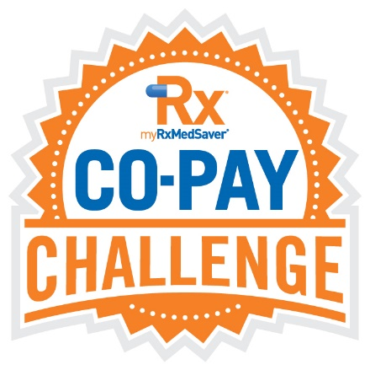
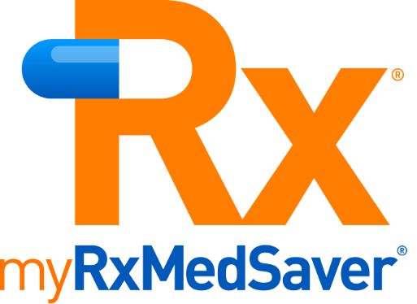

Below is possible wording for your HR department to use in its introduction email of the myRxMedSaver Prescription Discount Program to your team members.

*******

The HR department at [insert company name] is constantly looking for ways to help our team members. This past year’s significant jump in inflation has affected nearly every consumer purchase. Consequently, we’re introducing the myRxMedSaver Prescription Discount Program. It’s designed to curb prescription costs for you and your family.

The attached overview will give you the perfect launching point to learn more about the program, particularly how cash vs. co-pay pricing works. We found the video explaining this to be enlightening.

Let us hear from you what you think about the program and the results it provides.

*******

